

**An Analysis of Risk Associated with Saddle Pulmonary Embolism (PE)-**

**A Retrospective Review**

Terminology

**Acute pulmonary embolism (PE) -** The obstruction of a blood vessel by a foreign substance or a blood clot that travels through the bloodstream, lodging in a blood vessel, plugging the vessel. Foreign substances that can cause embolisms include air bubbles, amniotic fluid, globules of fat, clumps of bacteria, chemicals (such as talc), and drugs (mainly illegal ones). [Blood clots](https://www.medicinenet.com/blood_clots/article.htm) are the most common causes of embolisms. **A pulmonary embolus** is a blood clot that has been carried through the blood into the pulmonary artery (the main blood vessel from the heart to the lung) or one of its branches, plugging that vessel within the lung.

**Saddle pulmonary embolism –** is a large pulmonary embolism that straddles the bifurcation of the pulmonary trunk.

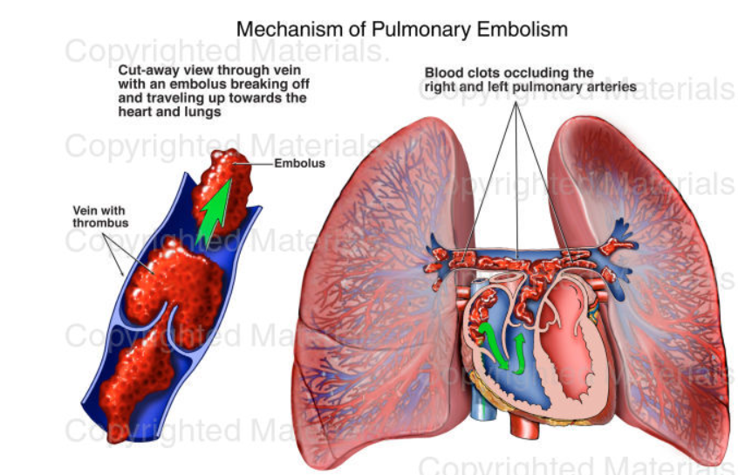[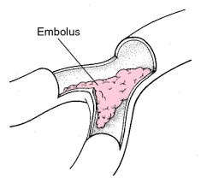](https://www.google.com/imgres?imgurl=https%3A%2F%2Fimg.tfd.com%2Fmk%2FE%2FX2604-E-22.png&imgrefurl=https%3A%2F%2Fmedical-dictionary.thefreedictionary.com%2Fsaddle%2Bembolus&docid=Z-HLrWJZcxm8DM&tbnid=j8ss2uWZnizZpM%3A&vet=10ahUKEwiL8c_iva_iAhUKpFkKHdfRA9YQMwiRASgmMCY..i&w=300&h=273&safe=active&bih=770&biw=1536&q=%20saddle%20pulmonary%20embolism&ved=0ahUKEwiL8c_iva_iAhUKpFkKHdfRA9YQMwiRASgmMCY&iact=mrc&uact=8)

**Pulmonary Embolism Severity Index (PESI)** – is a risk stratification tool to determine the mortality and outcome of patients with newly diagnosed pulmonary embolism (PE). It supports physicians in identifying those patients who could potentially be treated as an outpatient.

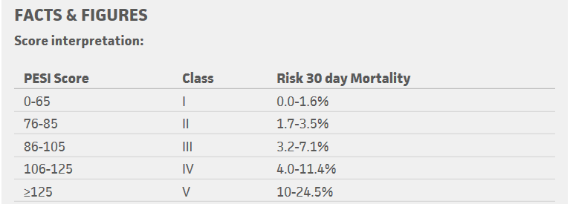

Variables that comprise the PESI score: age, sex, history of cancer/heart failure/chronic lung disease, Heart rate (HR) >110 bpm, Systolic Blood Pressure (SPB) <100 mmHg, Respiratory rate (RR) > or equal to 30, Temperature <36 degrees Celsius/ 96.8 degrees Fahrenheit, Altered mental status (AMS) (disorientation, lethargy, stupor, or coma), O2 saturation <90%.

Terminology –continued

**Simplified Pulmonary Embolism Severity Index (sPESI) –** is also a risk stratification tool to predict 30- day outcomes of a patient with PE, but with fewer criteria than the original PESI.

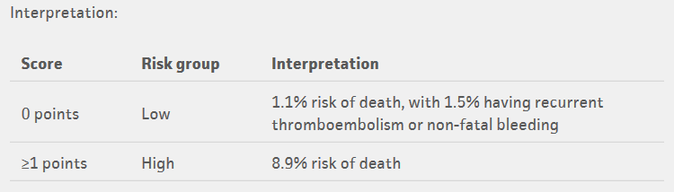

Variables that comprise the PESI score: age, history of cancer/cardiopulmonary disease, Heart rate (HR) >110 bpm, Systolic Blood Pressure (SPB) <100 mmHg, O2 saturation <90%.

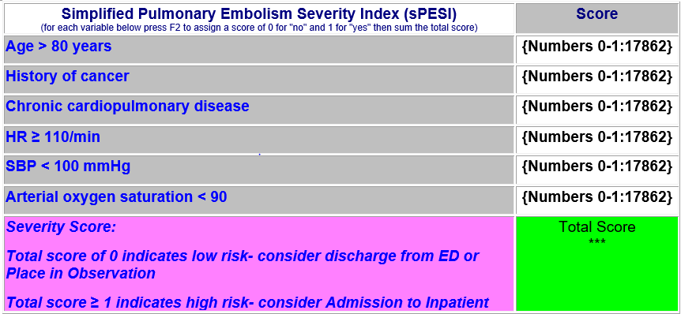

Low risk of death – defined as a simplified pulmonary embolism severity index (sPESI) = 0 (see smartphrase below for how to calculate sPESI score)

Patients must have sPESI score of zero and fulfill all of the bullet points below:

●Age less than 80 years old

●No requirement for supplemental oxygen

●No requirement for narcotics for pain control

●No respiratory distress

●Normal pulse and blood pressure

●No recent history of bleeding or risk factors for bleeding

●No serious comorbid conditions (eg, ischemic heart disease, chronic lung disease, liver or renal failure, thrombocytopenia, or cancer)

●Normal mental status with good understanding of risk and benefits, are not needle averse (if low molecular weight (LMW) heparin chosen), and have good home support (eg, do not live alone, have access to a telephone and physician, can return to the hospital quickly if there is clinical deterioration)

●Absence of concomitant deep venous thrombosis (a high clot burden in the lower extremities may increase the risk of death or warrant additional therapy)

●Not pregnant

Spreadsheet Terminology

**Oxygen (O2) saturation –** this is the amount of oxygen that is found in the blood. The normal range of oxygen saturation for adults is around 94 to 99%. Anyone with oxygen saturation level below 90% will likely require supplemental oxygen.

**Oxygen requirement –** amount of oxygen needed at or above what is found in the air (which is 21%) to help sustain normal oxygen hemoglobin (oxygen binds to red blood cells) levels necessary to support baseline organ function. This is monitored by a machine called a pulse oximeter, which can measure the amount of oxygen that is found in a patient’s blood that circulates throughout the body.

**Non-rebreather mask (NRB) -** There are different ways to provide higher concentration of oxygen to patients when saturation levels are below normal (90%). Devices range for low concentration delivery system like nasal cannula (a device that fits in the nose), various mask, and up to the high level of support mechanical ventilation. A nonrebreather mask has a reservoir (bag attached) allowing for delivery of higher concentration of oxygen (around 85 to 90%) to patients that have below normal oxygen saturations (<90%) that does not respond to other devices.

**Syncope -** is a temporary loss of consciousness usually related to insufficient blood flow to the brain. It's also called fainting or "passing out." It most often occurs when blood pressure is too low (hypotension) and the heart doesn't pump enough oxygen to the brain.

**Venous thromboembolism (VTE) -** is a condition in which a blood clot forms most often in the deep veins of the leg, groin or arm (known as deep vein thrombosis, DVT) and travels in the circulation, lodging in the lungs (known as pulmonary embolism, PE).

**Acute Deep Venous thrombosis (DVT) -** is a common condition that occurs in the legs of men and women of all ages. It causes leg swelling, pain and can limit walking. The larger the blood clot, the greater the number of veins that are damaged and the more severe are the symptoms.

**Brain Natriuretic Peptide (BNP) -** a test that measures the amount of the BNP [hormone](https://www.uofmhealth.org/health-library/sth149942#sth149942-sec) in your blood. BNP is made by your heart and shows how well your heart is working. Normally, only a low amount of BNP is found in your blood. But if your heart has to work harder than usual over a long period of time, such as from [heart failure](https://www.uofmhealth.org/health-library/sth123766#sth123766-sec), the heart releases more BNP, increasing the blood level of BNP.

**Troponin –** a test that measures the levels of troponin T or troponin I proteins in the blood. These proteins are released when the heart muscle has been damaged, such as occurs with a heart attack.